**CSCI 401 Project Meeting Minutes 2**

Time: 8:30-10:30PM

Date: Aug 29th 2017

Location: The Lorenzo

Attendance: James Tseng, Yining Huang, Mian Lu, Nelson Lin

Agenda:

* Summarization of today’s meeting
* Requirements for the project
* Proof of Concept
  + Data Structure/Primary Keys
  + ER Diagrams
  + Stored Variables
  + Extendibility
  + Normalization
  + Edge cases/possible problems with data
  + UI Functionality
* Division of Tasks (Due Sunday 6PM)

**Summarization:**

MOSCOW LIST

MUST HAVE

1. BOE DATA IMPORT
2. DESIGN DATA REPOSITORY
3. USER INTERFACE
   1. SCREEN TO VIEW PERSONAL TRAINING HISTORY
   2. SELF-REPORTING
   3. ADMIN SCREEN
4. REPORTING
   1. INDIVIDUAL TRAINING HISTORY
   2. AUTOMATED PDF GENERATION AND DISTRIBUTION
   3. USERS’ DASHBOARD: “QRYDATAENTRYDATABASE” QUERY
5. BROWSER COMPATIBILITY
   1. IE 10/11/CHROME/FIREFOX
   2. HTML5/CSS3

COULD HAVE

1. CARRY END CALCULATOR
2. VALIDATION

**Proof Of Concept**

**Data Structure/Primary Keys**

Employee ID and Certification No.

Problem we are currently facing:

* Appraisers all have Employee ID and Certification number, however, other employees may not have a certification number, therefore it can cause problems.
* Board of Equalization uses Certification number as their primary key

Possible Solutions:

* Hashing Employee ID and Certification number together to create a unique value
* Creating a lookup table to match employee ID and certification number, and the table will only be for appraisers/BOE data → Use Employee ID as primary key

**System architecture**

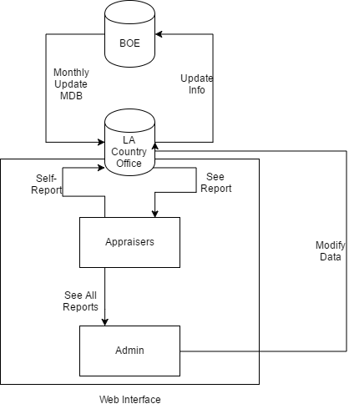

**ER Diagrams**

**Stored Variables**

BOE variables:

Annual Requirement:

* Last Name, First Name, Middle Name, Cert. No., County Code, County Name, Temporary Cert. Date, Perm. Cert. Date, ADV Cert. Date, Current Status, Status, Cert. Type, Fiscal Year, Earned Hours, Required Hours, Current year Balance, Prior year balance, Carry to year 1, Carry to year 2, Carry to year 3, Carry forward total

Details

* County Code, County Name, Certification No., Last Name, First Name, Middle Name, Fiscal Year, End Date, Course, Location, Grade, Hours Earned

Summary

* County Code, County Name, Fiscal Year, Last Name, First Name, Middle Name, Cert. No., Auditor, Carry Forward, Certificate Type

LAC variables:

**Extendibility**

* Other employees (without certification number)
* Variables from LA county Assessor's office

**Normalization**

* Database normalization, or simply normalization, is the process of organizing the columns (attributes) and tables (relations) of a relational database to reduce data redundancy and improve data integrity. Normalization is also the process of simplifying the design of a database so that it achieves the optimal structure. It was first proposed by Edgar F. Codd, as an integral part of a relational model. (Wikipedia)

**Edge cases/possible problems with data and Validation**

* Bad Data (Typographical Errors)
* Duplication
* Input Field Standardization
* Employee ID doesn’t match name

**UI Functionality**

* Self-Reporting/Updating information such as classes, personal data

**Division of Tasks**

* Frontend: James Tseng and Nelson Lin
  + Frontend backend connection
  + Web UI design
  + Functionality
  + Sessions
  + PHP/CSS3/HTML5
* Backend: Mian Lu and Yining Huang
  + Frontend backend connection
  + Data Structure
  + Importing Data
  + ER Diagram
  + Microsoft Access/Microsoft SQL
  + Extendibility
  + Normalization